## SHRI VAISHNAV VIDYAPEETH VISHWAVIDYALAYA



**Department – Information Technology Session – Jan-july 2021**

## Group No. 8 Project Report

**on**

## Study Point Learning Application

**Submitted by Guided by :**

## Adarsh Gyan Rawat [18100BTIT03052] PROF. RANI SINGH Aditya Maheshwari [18100BTIT03055]

**Chetan Mehta [18100BTIT03073] Rahul Nair [18100BTIT03107]**



**DEPARTMENT OF INFORMATION TECHNOLOGY**

**DECLARATION**

## We here declare that work which is being presented in the project entitled “Study Point Learning Application” in partial fulfillment of degree of **Bachelor of Technology in Information Technology** is an authentic record of our work carried out under the supervision and guidance of **Ms. Rani Singh** Asst. Professor of Information Technology. The matter embodied in this project has not been submitted for the award of any other degree.

Date:

Student 1 Signature

Student 2 Signature



**SHRI VAISHNAV INSTITUTE OF INFORMATION TECHNOLOGY DEPARTMENT OF INFORMATION TECHNOLOGY**

### PROJECT APPROVAL SHEEET

Following team has done the appropriate work related to the **“Study Point Learning Application”** in partial fulfillment for the award of **Bachelor of Technology in Information Technology** of “SHRI VAISHNAV INSTITUTE OF INFORMATION TECHNOLOGY” and is being submitted to SHRI VAISHNAV VIDYAPEETH VISHWAVIDYALAYA, INDORE.

Team:

1. **Adarsh Gyan Rawat**
2. **Aditya Maheshwari**
3. **Chetan Mehta**
4. **Rahul Nair**

Prof. RANI SINGH

## Internal Examiner External Examiner

Date : 09-06-21



**SHRI VAISHNAV INSTITUTE OF INFORMATION TECHNOLOGY DEPARTMENT OF INFORMATION TECHNOLOGY**

**CERTIFICATE**

1. This is to certify that **Mr.Adarsh Gyan Rawat, Mr. Aditya Maheshwari Mr. Chetan Mehta and Mr.Rahul Nair** working in a team have satisfactorily completed the project entitled **“Study Point Learning Application”** under the guidance of **Ms. Rani Singh** in the partial fulfillment of the degree of **Bachelor of Technology in Information Technology** awarded by SHRI VAISHNAV INSTITUTE OF INFORMATION TECHNOLOGY affiliated to SHRI VAISHNAV VIDYAPEETH VISHWAVIDYALAYA, INDORE during the academic year **July 2020-Dec 2020**.

|  |  |
| --- | --- |
| (Name of Guide 1) |  |
| (Name of Guide 2) | Prof. Rani Singh |
| **Project Guide** | **Project Coordinator** |

Dr. Jigyasu Dubey

**Head, Department of Information Technology**

# ACKNOWLEDGEMENT

We are grateful to a number of persons for their advice and support during the time of complete our project work. First and foremost our thanks goes to **Dr. Jigyasu Dubey** Head of the Department of Information Technology and **Ms. Rani Singh** the mentor of our project for providing us valuable support and necessary help whenever required and also helping us explore new technologies by the help of their technical expertise. His direction, supervision and constructive criticism were indeed the source of inspiration for us.

We would also like to express our sincere gratitude towards our Director **Dr. Anand Rajavat** for providing us valuable support.

We are really indebted to **Prof. Rani Singh,** project coordinator for helping us in each aspect of our academics activities. We also owe our sincere thanks to all the **faculty members** of Information Technology Department who have always been helpful.

We forward our sincere thanks to all **teaching and non-teaching staff** of Information Technology department, SVVV Indore for providing necessary information and there kind co-operation.

We would like to thanks our parents and family members, our classmates and our friends for their motivation and there valuable suggestion during the project. Last, but not the least, we thank all those people, who have helped us directly or indirectly in accomplishing this work. It has been a privilege to study at SHRI VAISHNAV VIDYAPEETH VISHWAVIDYALAYA, INDORE

**Abstract**

Sign language is the preferred method of communication among the deaf and the hearing impaired people all over the world. Recognition of sign language can have varying degree of success when used in a computer vision or any other methods. Sign language is said to have a structured set of gestures in which each gesture is having a specific meaning.

Our project is an effort towards studying the challenges in classification of characters in Indian Sign Language(ISL). A lot of research has been done in the corresponding field of American Sign Language(ASL), but unfortunately the same cannot be said for ISL. Lack of standard datasets, occluded features and variation in the language with locality have been the major barriers which has led to little research being done in ISL.

Sign language is used by deaf and hard hearing people to exchange information between their own community and with other people. Computer recognition of sign language deals from sign gesture acquisition and continues till text/speech generation. Sign gestures can be classified as static and dynamic. However static gesture recognition is simpler than dynamic gesture recognition but both recognition systems are important to the human community.

The sign language recognition steps are described in this survey. The data acquisition, data preprocessing and transformation, feature extraction, classification and results obtained are examined. Some future directions for research in this area also suggested

**TABLE OF CONTENT**

Declaration

Project Approval Sheet Certificate Acknowledgment Abstract

List of Figures

CHAPTER 1 – **INTRODUCTION**

* 1. Introduction
  2. Problem Statement
  3. Need for the proper System
  4. Objective
  5. Modules of the system
  6. Scope

CHAPTER 2 - **LITERATURE SURVEY**

* 1. Existing System
  2. Proposed System
  3. Feasibility Study
     1. Technical Feasibility

2.3.1 Economical Feasibility

2.3.1 Operational Feasibility

CHAPTER 3 – **REQUIREMENTS ANALYSIS**

* 1. Method used for Requirement analysis
  2. Data Requirements
  3. Functional Requirements
  4. Non Functional Requirements
  5. System Specification
     1. Hardware specification
     2. Software Specification CHAPTER 4 – **DESIGN**
  6. Software Requirements Specification
     1. Glossary
     2. Supplementary Specifications
     3. Use Case Model
  7. Conceptual level class diagram
  8. Conceptual level activity diagram
  9. Data flow Diagram( Level 0,1,2)
  10. Database Design (ER-Diagram)

I II III IV V

VI 1-20

p.no.

p.no.

p.no.

p.no.

p.no.

p.no.

21-30

p.no.

p.no.

p.no.

p.no.

p.no.

p.no.

31-40

p.no.

p.no.

p.no.

p.no.

p.no.

p.no.

p.no.

p.no.

41-50

p.no.

p.no.

p.no.

p.no.

p.no.

p.no.

p.no.

|  |  |  |
| --- | --- | --- |
| CHAPTER 5 – **SYSTEM MODELING** | | 51-60 |
| 5.1 | Detailed Class Diagram | p.no. |
| 5.2 | Interaction Diagram | p.no. |
|  | 5.2.1 Sequence Diagram | p.no. |
|  | 5.2.2 Collaboration Diagram | p.no. |
| 5.3 | State Diagram | p.no. |
| 5.4 | Activity Diagram | p.no. |
| 5.5 | Object Diagram | p.no. |
| 5.6 | Deployment Diagram  Test Plans and Implementation Images | p.no. |
| CHAPTER 6 – **CONCLUSION & FUTURE WORK** | | 71-72 |
| 6.1 | Limitation of Project | p.no. |
| 6.2 | Future Enhancement | p.no. |
| CHAPTER 7 - **BIBLIOGRAPHY & REFERENCES** | | 73-75 |

* 1. Reference Books
  2. Other Documentations & Resources

**Minor Project Report**

**Study Point Application**

**Chapter-1**

* 1. **INTRODUCTION**

Nowadays, mobile devices have become a way of life for students especially in higher education. Computers are replaced by compact smart phones that can fit into pocket and can be carried anywhere.

The rapid progress in mobile technology has created a new area which is known as Mobile Learning. Mobile Learning is the next level of learning and teaching process. Also on the other hand the books which may be the reference book and the other publications are costly and difficult to prepare for examination as well as teaching point of view.

Also students who can’t afford the reference books can also be benefited by this application. With development of this Android Applications the student would prefer use of mobile devices with educational tool.

Also by developing this app the students and professors would get connected to each other across the globe and can be helpful to each other in context for development related work . They may have suggestions on different ideas and projects from experts and make the best out of there learning and skills sets.

Smart phones are based on operating systems like Android. To design proposed project, smart phones with Android operating system is chosen because penetration rate of Android OS is 70 percent. It is open source and freeware. The application is compatible with all Android versions ranging from Android 6.0 to Android 10.0.

* 1. **PROBLEM STATEMENT**

As more and more students are using internet to find resources for their study material it is been quite difficult to find good resources and also it is time consuming , because enormous amount and variety of resources available on the internet.

And the doubts of students are not clearing properly ,also they are getting difficulty to find proper content so that they left with incomplete knowledge about the topic. Due to the vast syllabus of the subjects being taught in the institution ,Student are unable to find the important topics of their subjects.

**1.3 NEED FOR THE PROPER SYSTEM**

A proper system is very important for students to access the resources instead of Searching for hours on internet for study resources and also for finding previous year papers they have to contact for their friends then also sometime they are not getting papers, to solve this problem a proper platform where student can find all their necessary resources within a single platform.

A proper system is where the students can post the doubts and get answers form verified sources, so they don’t have to search on various other sites , all their study related doubts will be solved on a common platform. And the student can easily prepare for Examination by giving previous years papers.

**1.4 OBJECTIVE**

The Objective of our work is to design a robust and efficient system to solve the problem of many students/freshers face to find the right study material ( Proper notes, Previous year papers ,Book

**1.5 MODULES OF THE SYSTEM**

* **Sign up Module** : details of the user and verification using student information at the back-end.
* **Login Module** : user verification using registered phone number.
* **Dash-Board Module** : all the user data and recommend data will be displayed on the Dash-Board Screen.
* **Communication Module** : the module will provide one-to-one communication for user.
* **Forum Module** : the module will provide group of various technical topics where user can post their doubts and get answer.
* **Resources Module** : this module resources available on the application in hierarchical order(Institute->Branch->Semesters->Subjects->(book , notes , paper))

**1.6 Scope**

Online learning is a wide platform to help students get more educated. With the E-Learning, the concept of learning has differed from the old times. This e-learning platform is widely increased as the each individual contains a smart phone with internet through which, each can access the resources on the websites in minutes.

**Chapter-2**

**2.1 EXISTING SYSTEM**

In the current scenario student had to face various problem like:

* Students have to search books , PDF on various platform , sometimes it become very hard to find good resource.
* Students have to visit various sites (stack-overflow , Quora , geeksforgeeks etc.) to solve their doubts.(some time its very time consuming)
* It is very hard to find good handwritten notes on the internet .
* Many websites or app don’t have any doubt session or any type of assessment.

**2.2 PROPOSED SYSTEM**

* The purpose of this project is to create an application for students to provide proper platform for study and assess themselves .
* Students using this application will be able to use an easy to use interface in order to solve doubts, solving papers and downloading notes of different users.
* Verified notes should be provided and User authentication is necessary for security purpose , one time password will be sent on registered mobile number to login .
* One of the main purpose of this project is that student can easily get verified notes , previous year papers and books of different author on one single app.
* So that student can save their time on searching notes and also they can save their money in purchasing books.
* In this application we are providing one communication mode in that student can communicate with other to clear their doubts.
* So that on one platform student can learn , assess themselves and easily clear their doubts.

**2.3 FEASIBILITY STUDY**

**2.3.1 TECHNICAL FEASIBILITY**

* Minimum 8GB ram or above.
* Intel i5 processor or above is required.
* Android Studio for Application Development.
* Firebase used as a database.
* GitHub is used for managing project repositories.

**2.3.2 OPERATIONAL FEASIBILITY**

The organization ready for the project and its impact and what are the business, cultural, legal and other hurdles that might stop it from working in practice.

* The Application is fully GUI based that is very user friendly and all inputs to be taken all self-explanatory.
* The application resource data will save the data on the local storage in the user systems.
* The User profile data will be stored on cloud database.

**2.3.3 ECONOMICALLY FEASIBILTY**

Economic analysis is most frequent used for evaluation of the effectiveness of the system. More commonly known as cost /benefit analysis the procedure is to determine the benefit and saving that are expected from a system and compare them with costs , decision is made to design and implement the system.

This part of feasibility study gives the top management the economic justification for the new system.

**Chapter 3**

**3.2 DATA REQUIREMENTS**

* Branch Information: various subjects in the branch
* Semester Information: various subjects been taught in the semester
* Subject Information:
* Various books , reference books used by the faculties
* Notes used by the faculties
* Previous Year Papers

**3.3 FUNCTIONAL REQUIREMENTS**

**3.3.1 For Users**

**R.1 Create Account**

R.1.1 Login (Existing User)

R.1.2 Sign-up (New User and also verify by Admin)

**R.2 Home Page**

R.2.1 Pin Document

R.2.2 Pin Directory (Related Department)

R.2.3 Blocks

R.2.3.1 Trending Paper (Related Department)

R.2.3.2 Trending Competitive Exam (Related Department)

R.2.4 Add/Delete Documents (Links, Books, Hand Written Documents, Paper )

R.2.5 Drawer

R.2.5.1 Profile

R.2.5.1.1 Complete Profile

R.2.5.1.2 Edit Profile

R.2.5.1.3 View Profile

R.2.5.2 Setting (Settings Related to Application)

R.2.5.3 About

R.2.5.4 Saved Document

R.2.5.5 Your Highlights

R.2.6 Event Announcement

**R.3 Search Section** (Search documents, Students, paper, Institute, Department, Processor, Groups, Relevant Questions etc)

R.3.1 Apply Filter (To Concentrate Related Search)

R.3.2 Saved Document (On click on Download)

R.3.3 View Documents (Without Download or Save)

R.3.4 Rate That Document

R.3.5 Block That Document

R.3.6 Share to Any One

R.3.7 Delete Older Document (means Delete that document because that is old and not usable)

**R.4 Forum Section** (Doubt Section)

R.4.1 Filter (To Categorize)

R.4.2 Ask Question

R.4.3 Say Answer

R.4.4 Rate Answer

R.4.5 Share Doubt To Any-One

R.4.6 Create Group Related Doubt (Like M1,M2,M3)

R.4.7 Join Group

R.4.8 Communicate Directly (One to One)

**R.5 Person Section**

R.5.1 View Profile (Any One Use That Application)

R.5.2 Follow Person (To Follow Their High Lights and Instruction)

R.5.3 Report

R.5.4 Ask To Add Your Group

**3.3.2 Admin** (Creator)

**R.1 Manage Users** (Reported Users)

**R.2 Manage Documents** ( and any useless documents and Reported Documents)

**R.3 Change Rules**

**R.4 Manage Category**

**R.5 update Structure**

**R.6 Add/Delete Admin**

**R.7 Approve User verification**

**3.4 NON-FUNCTIONAL REQUIREMENTS**

* Gathering data for the application. (books, notes, paper in digital form)
* User-Friendly GUI for Login Sign up.
* Dashboard for user related Resources.
* Chatting section for student-to-student communication.
* Forum/Discussion section for student doubts.

**3.5 SYSTEM SPECIFICATION**

Technologies used:

* Android Studio
* Firebase:
* Real-time database
* Cloud storage
* Authentication
* XML
* Java
* GitHub

**3.5.1 HARDWARE SPECIFICATION**

* Snapdragon 407 Soc and above
* MediaTek's P60 and P70 Soc and above
* 1 GB RAM and above
* 120 MB Storage and above

**3.5.2 SOFTWARE SPECIFICATION**

* Android Studio 6.0
* Firebase
* GitHub
* Emulator
* Operating System: Windows/Linux

**3.6 GOALS OF IMPLEMENTATIONS**

* User will be able to provide and use notes provided by other student and teacher.
* User does not to be depend on other students for study resources.
* User will be able share there doubt in the doubt section and get response by verified user.
* User resource will be stored in a structured format ,which make it easier for them to access any resource at any time.
* User will not have to download resource on their smartphone , they will be able to access all the resource available on the application directly from the cloud.

**Chapter 4-DESIGN**

**4.1 Function Oriented Design**

**4.1.1 DFD Level 0 Design**

**Fig 4.1.1: - DFD Level 0**

**4.1.2 DFD Level 1 Design**

**Fig 4.1.2: - DFD Level 1**

**4.2Use Case Diagram**

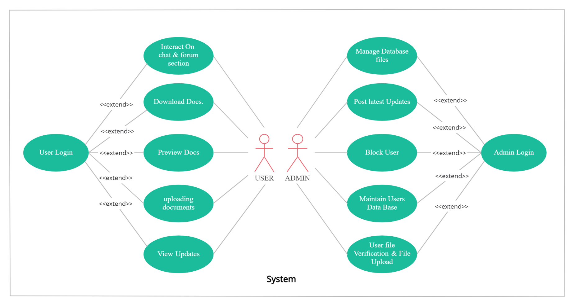

**Fig 4.2.1: - Use Case Diagram**

**4.3 Activity Diagram**

**Fig 4.3.1: -User Activity Diagram**

**Fig 4.3.2: - Admin Activity Diagram.**

**4.4 Sequence Diagram.**

**Fig 4.4.1:-Sequence Diagram.**

**4.5 Class Diagram**

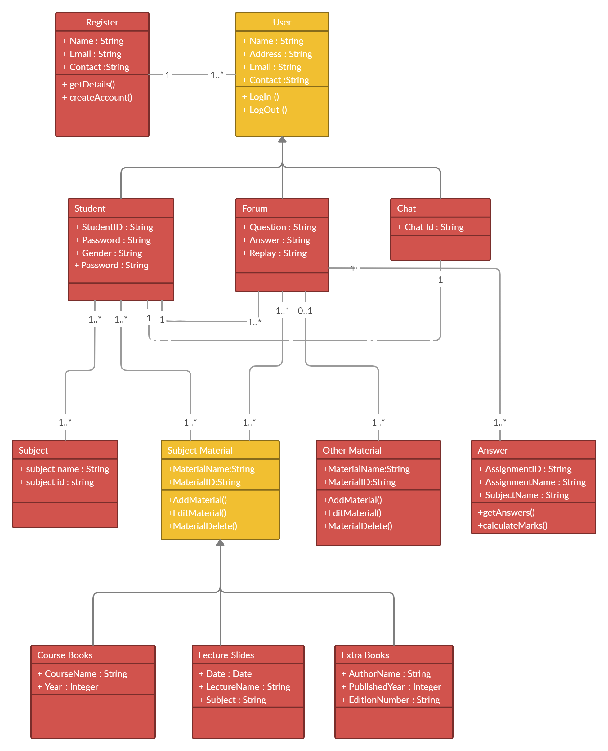

**Fig 4.5.1:-Sequence Diagram**

**Overview**

1. **StudyPoint Introduction**

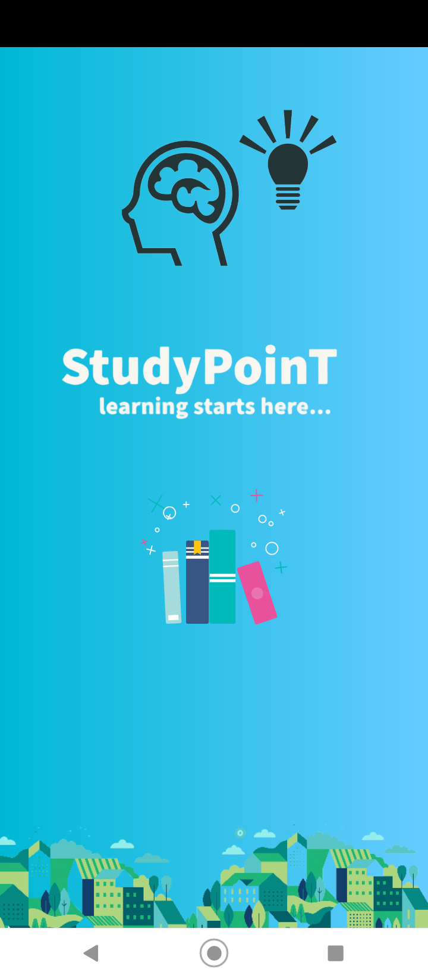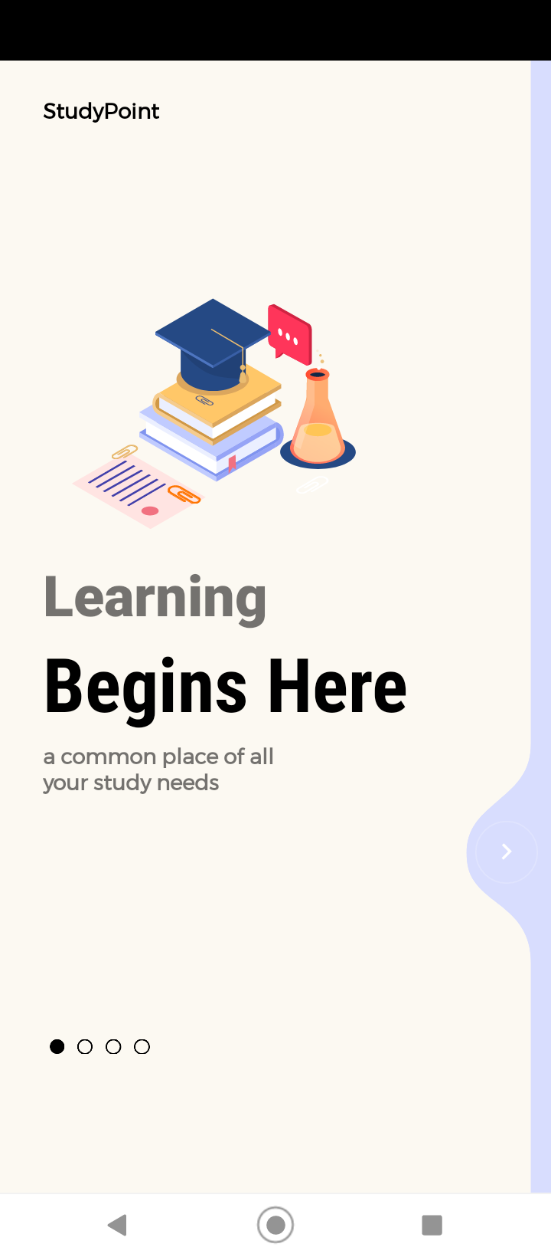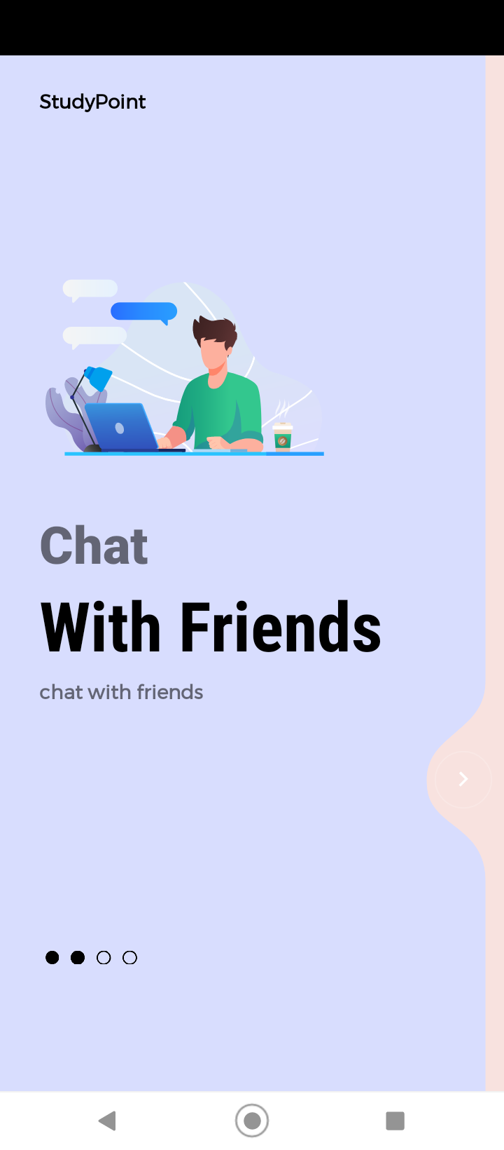**1.1 1.2 1.3**

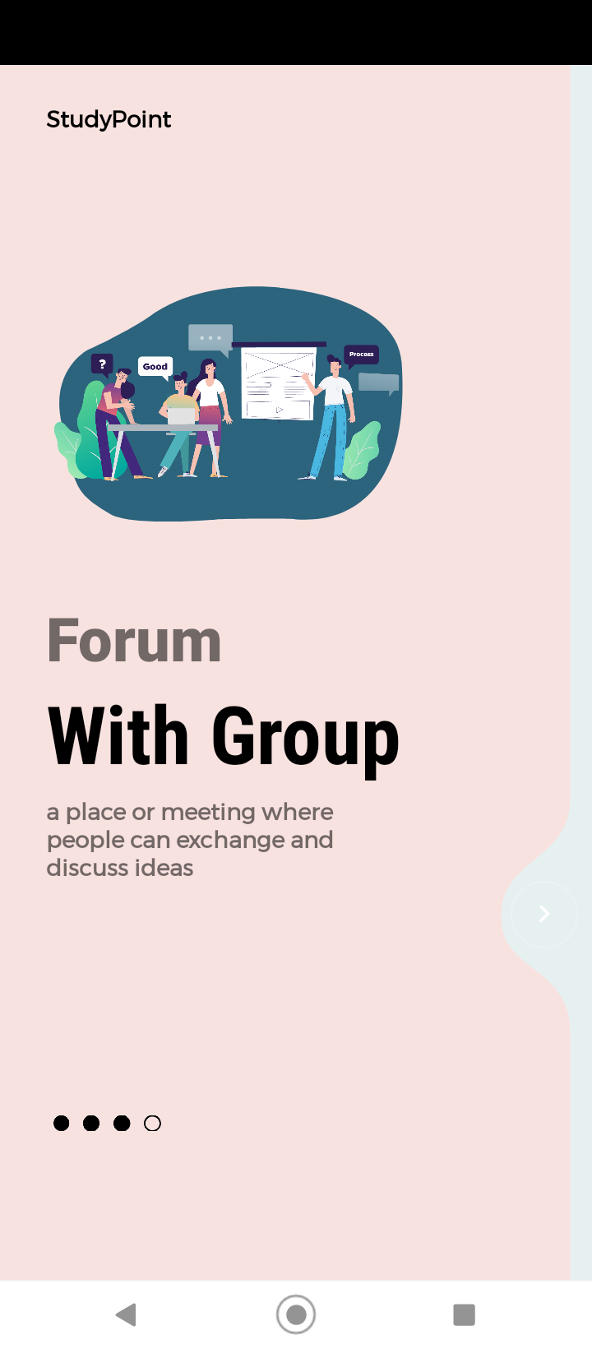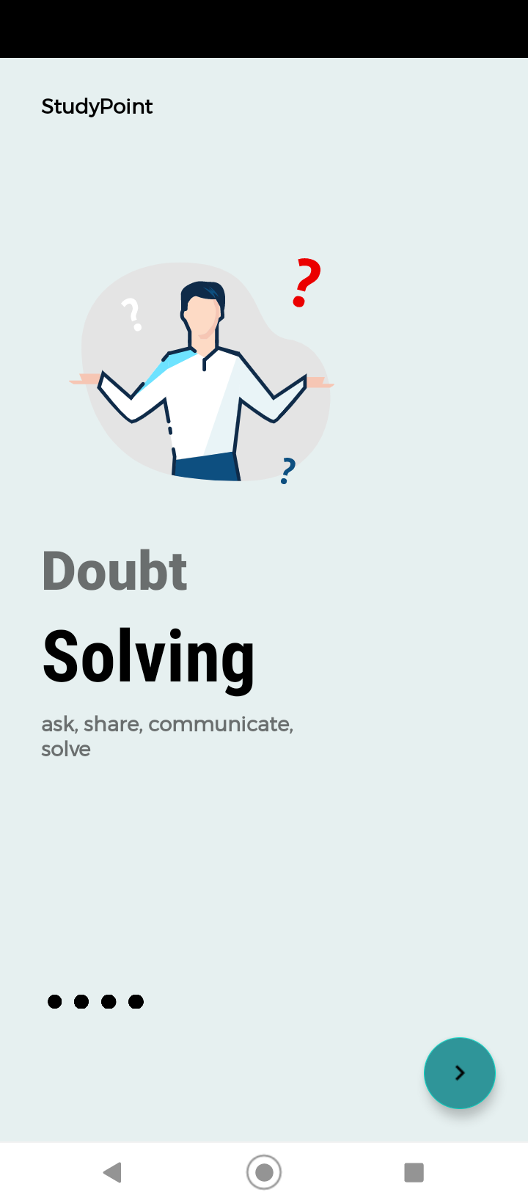

**1.4 1.5**

1. **StudyPoint Registration**

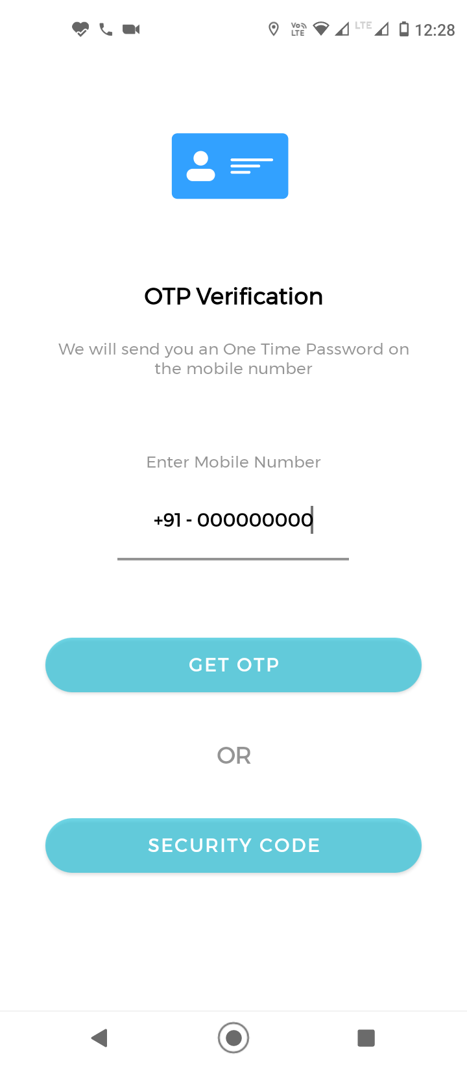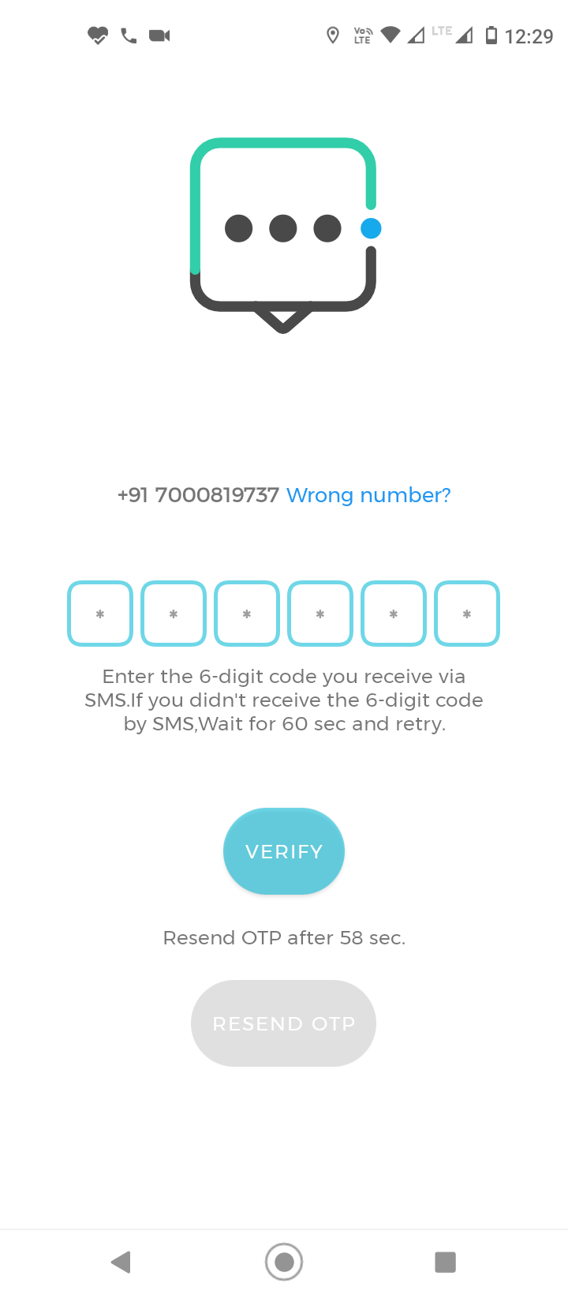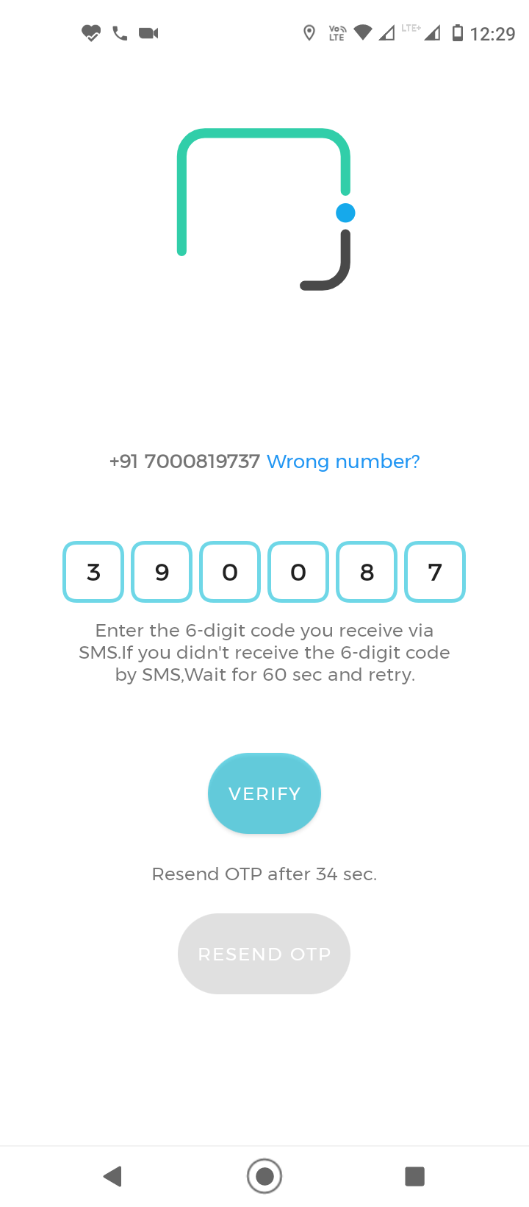

**2.1 2.2 3.3**

1. **StudyPoint Registration**

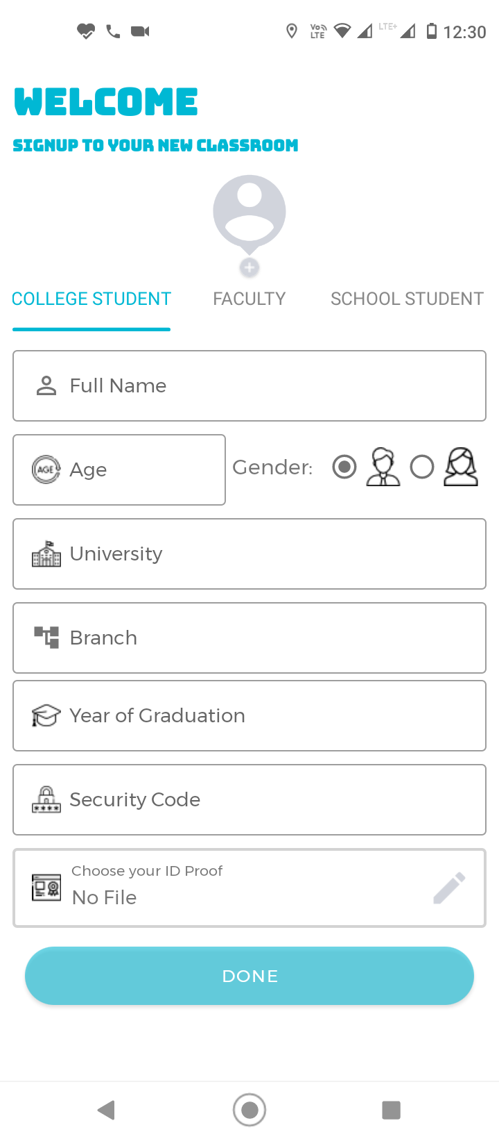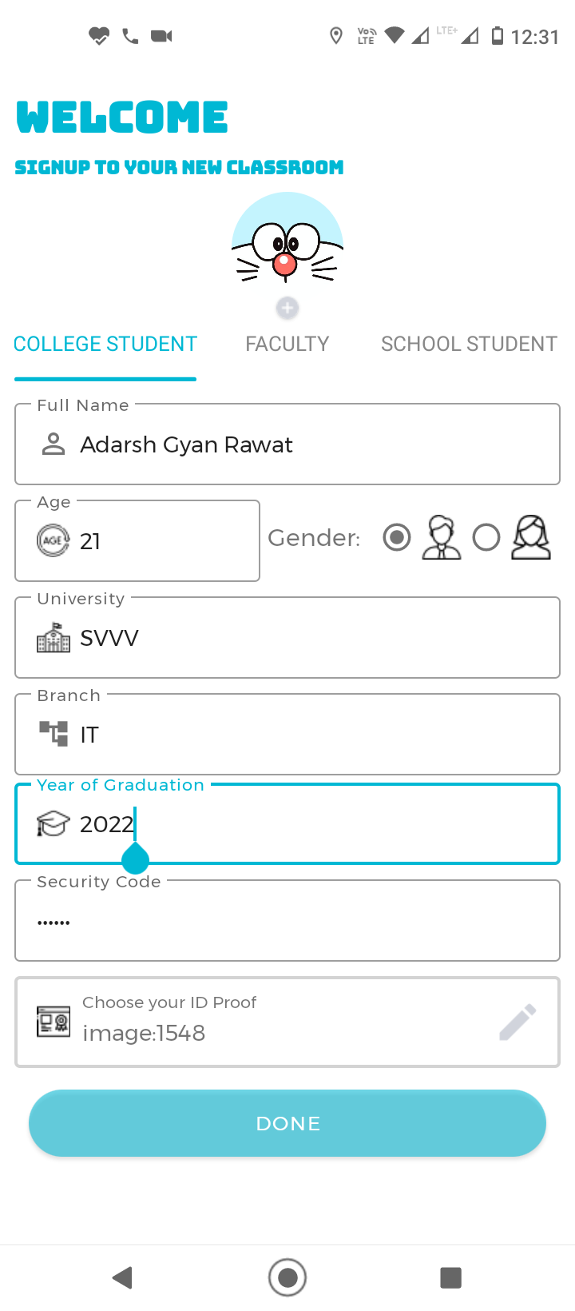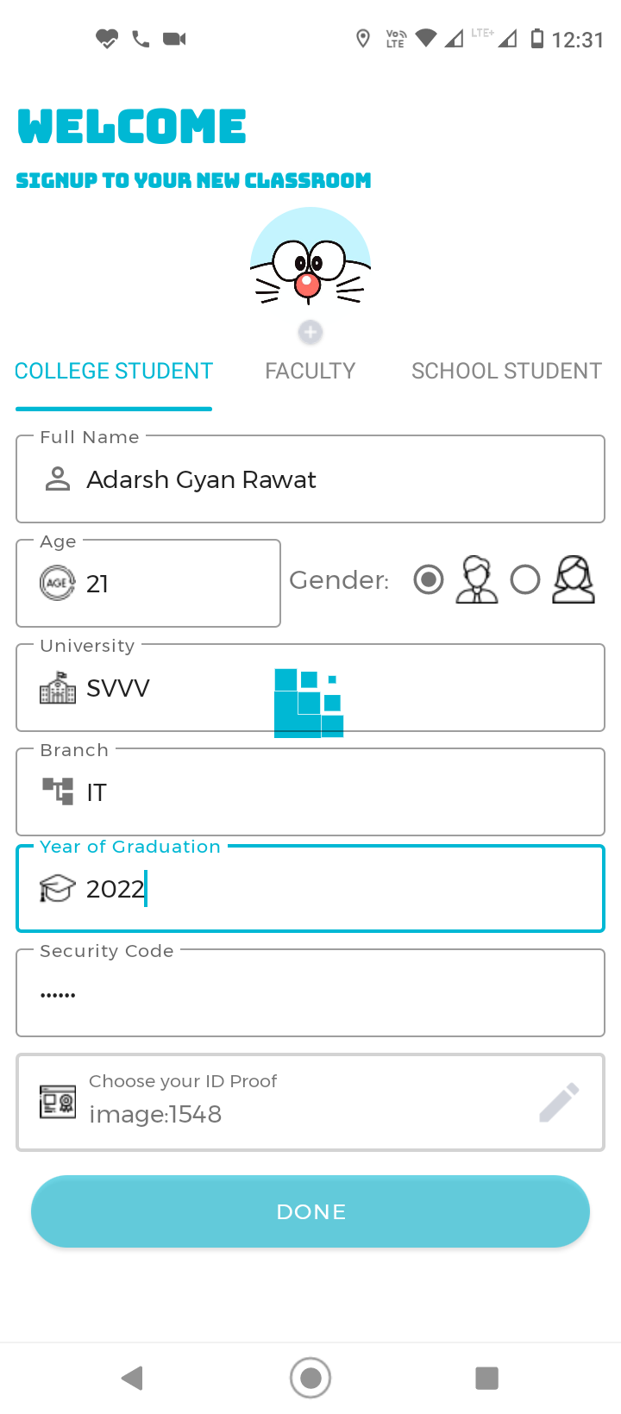

**3.1 3.2 3.3**

1. **StudyPoint Dashboard Icons**

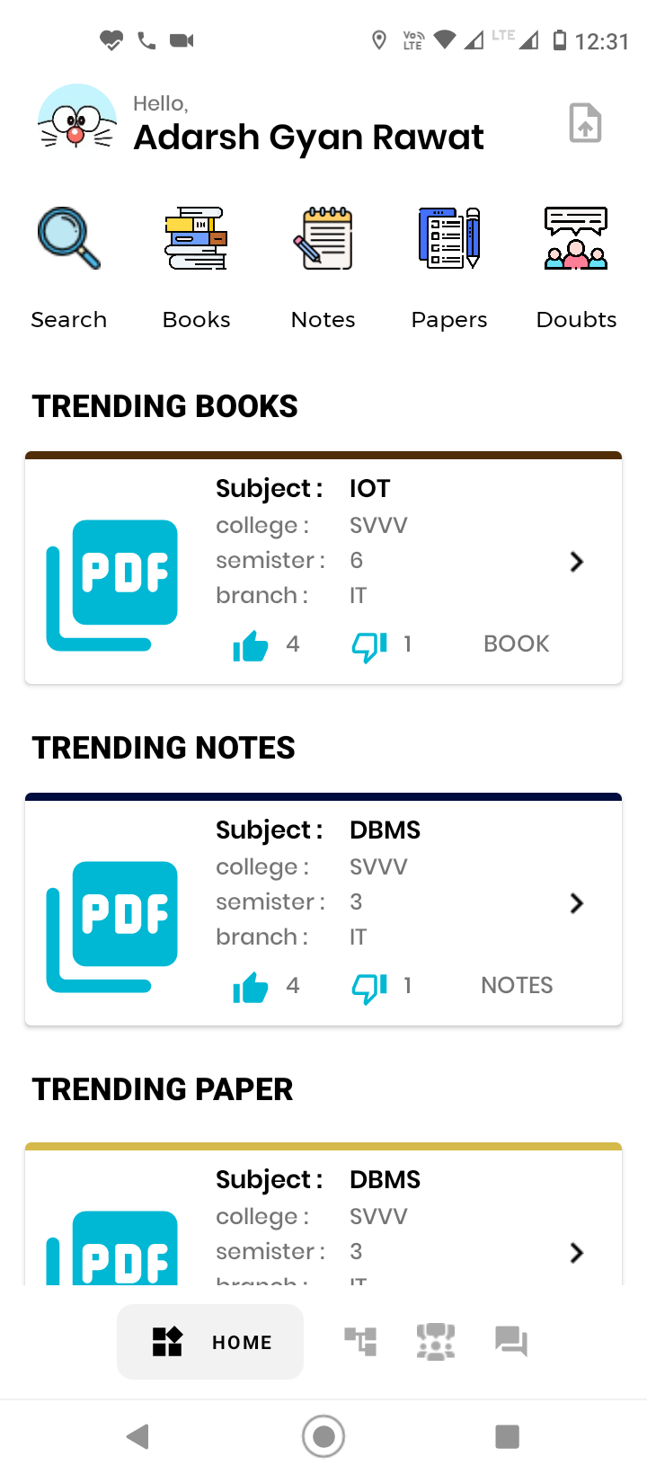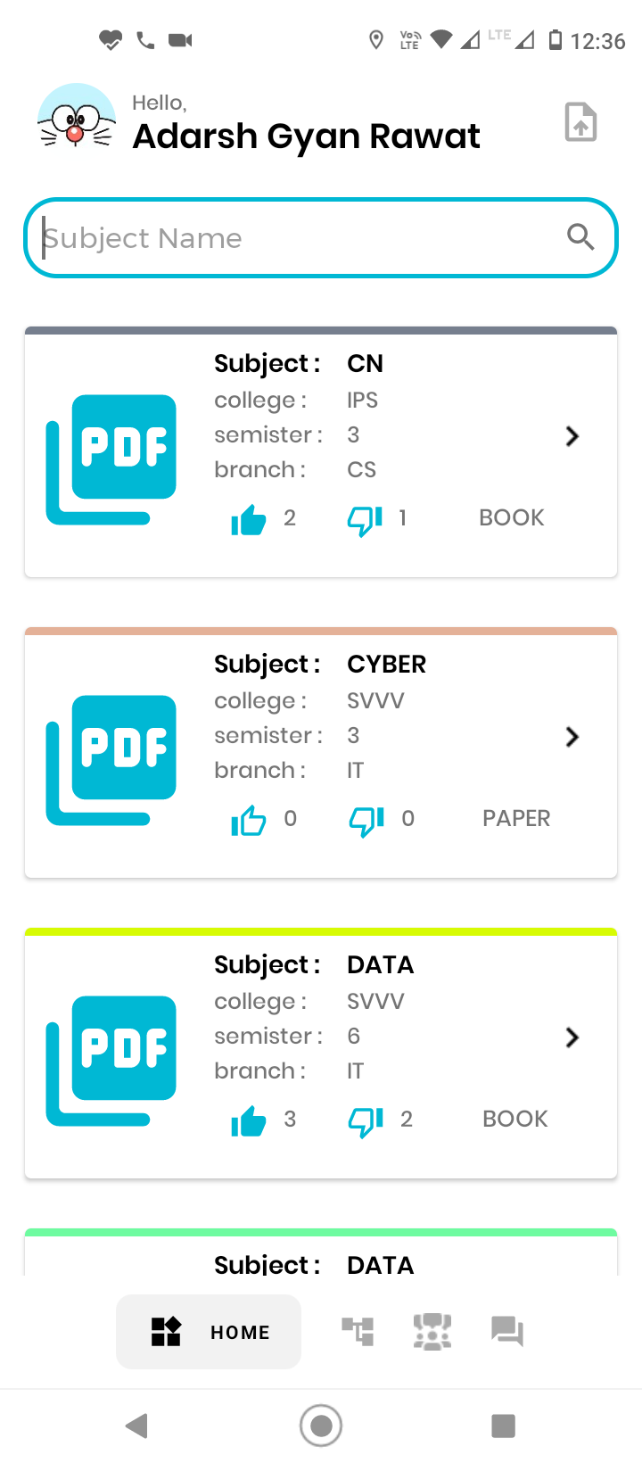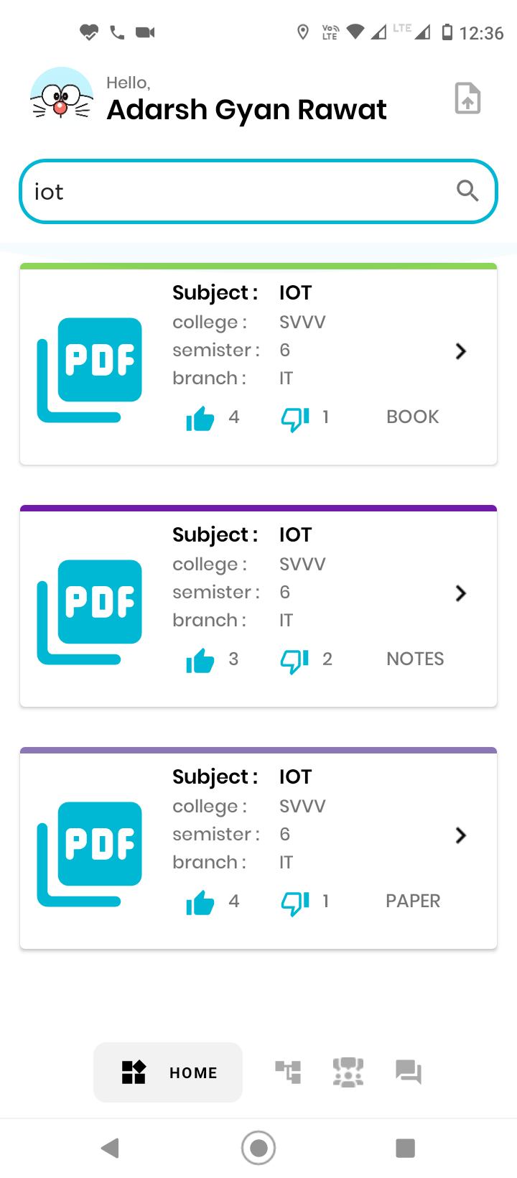

**4.1 4.2 4.3**

1. **Icon Selection**

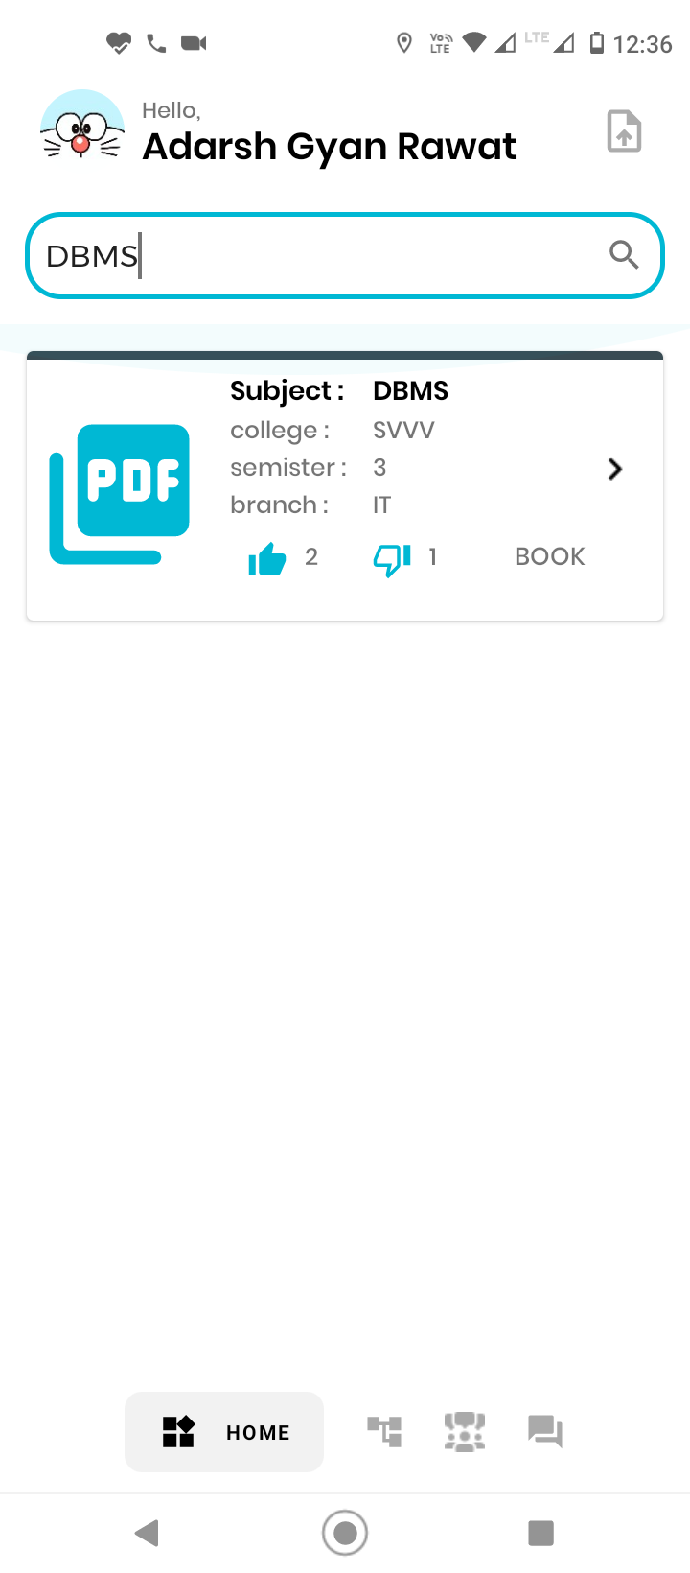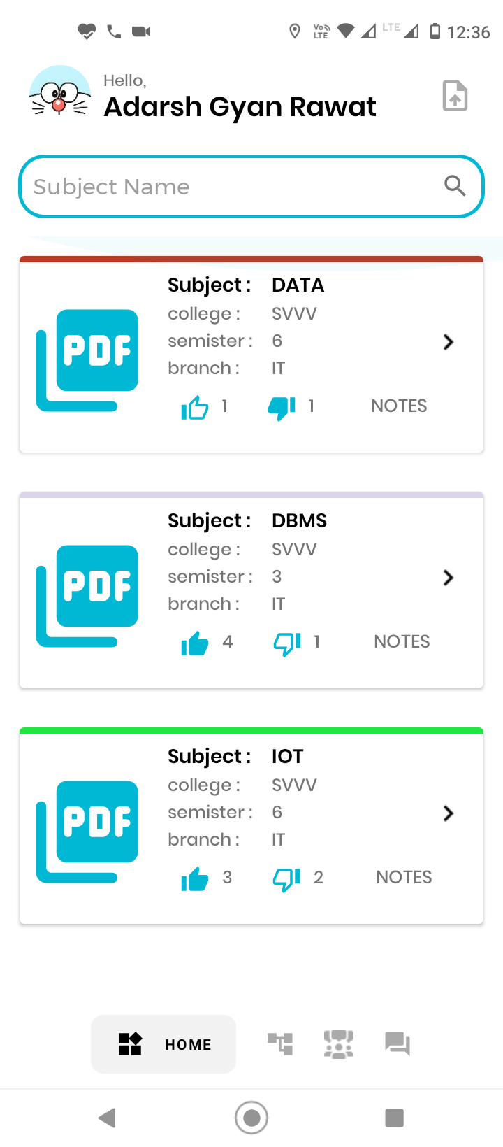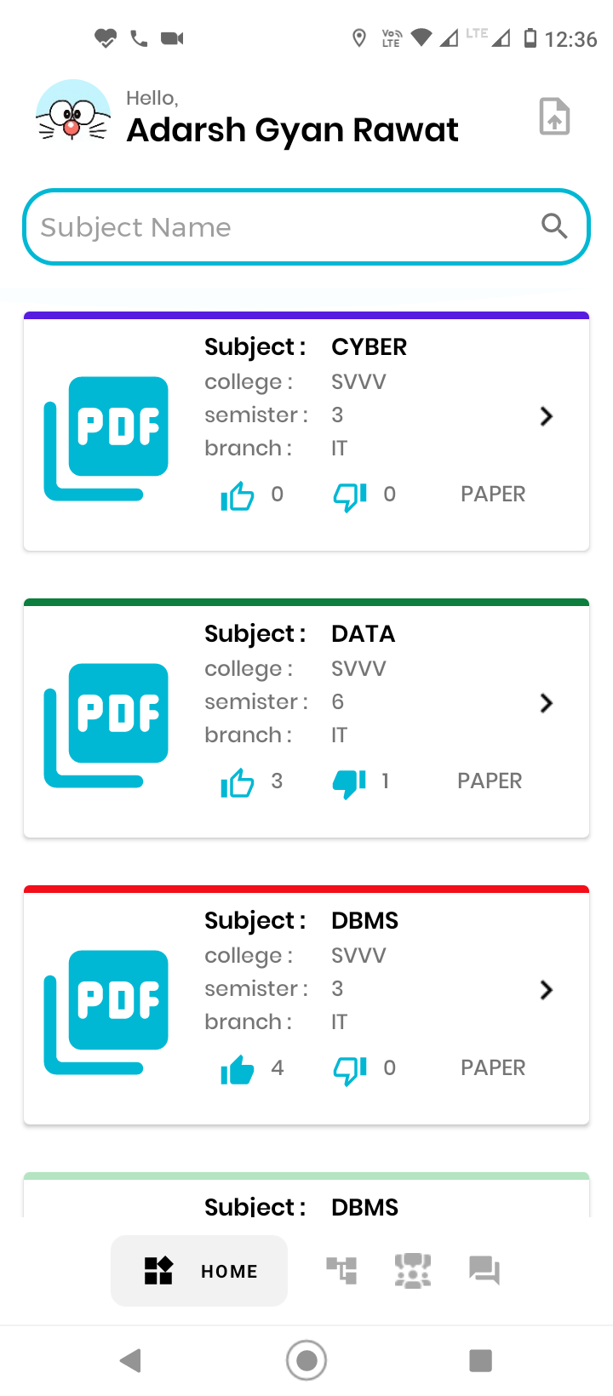

**5.1 5.2 5.3**

**6. Study-Resource Branches**

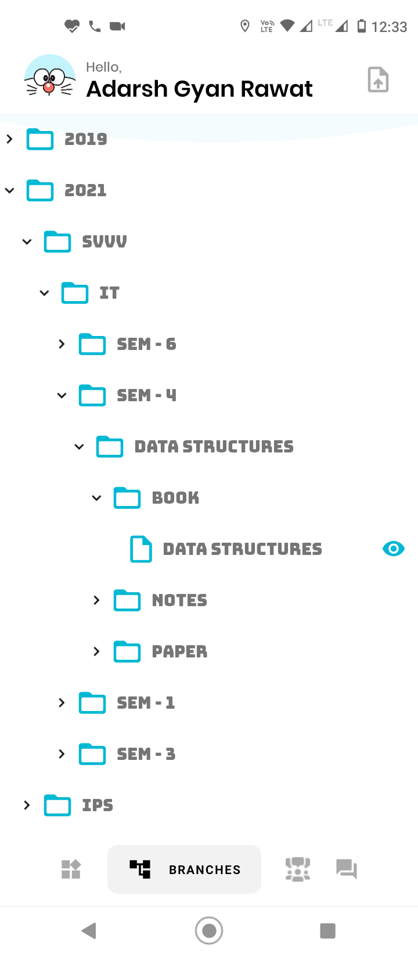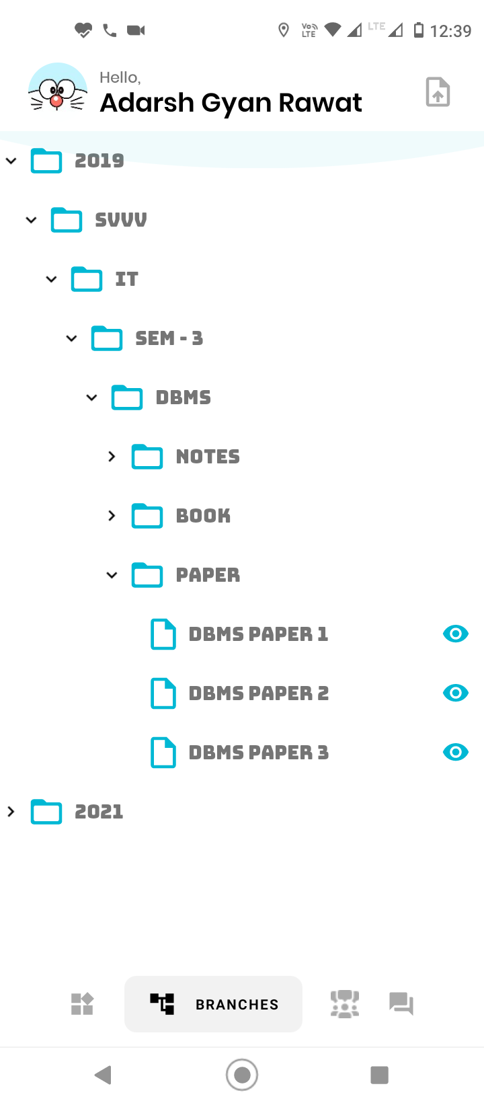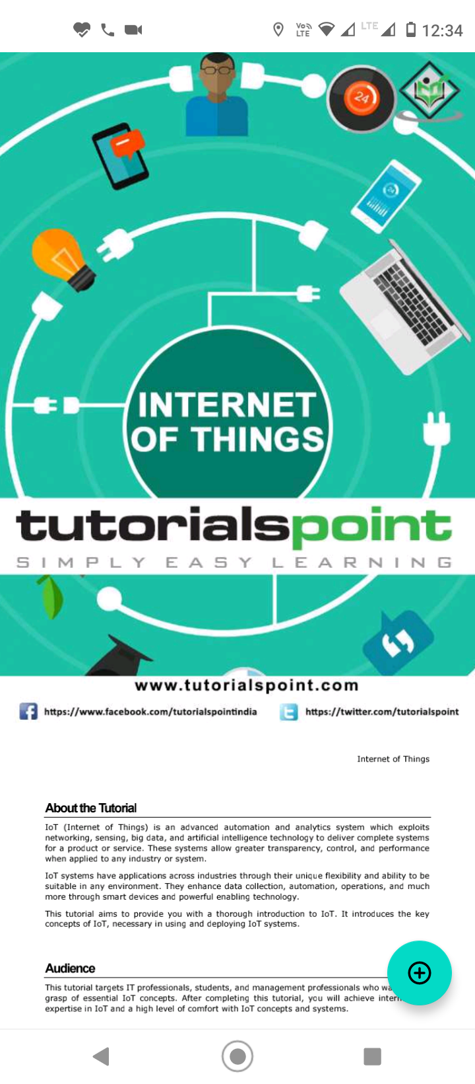

**6.1 6.2 6.3**

**7. Upload-Study-Resources(Verified User-Only)**

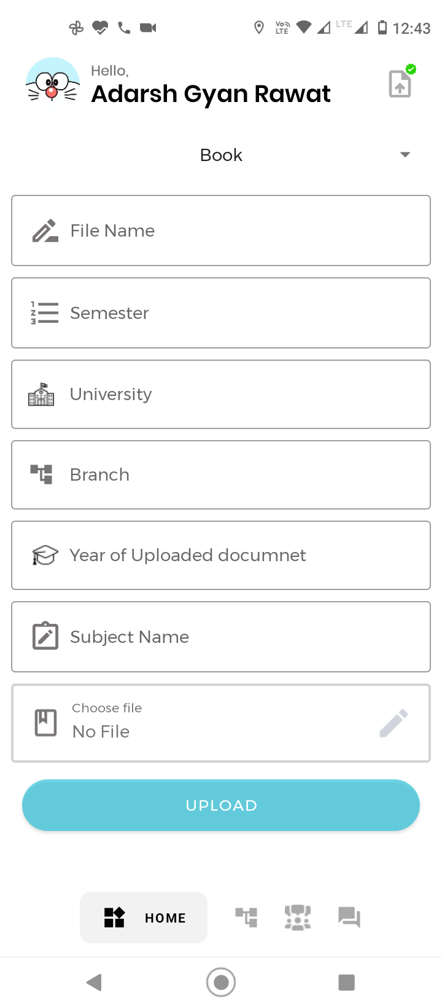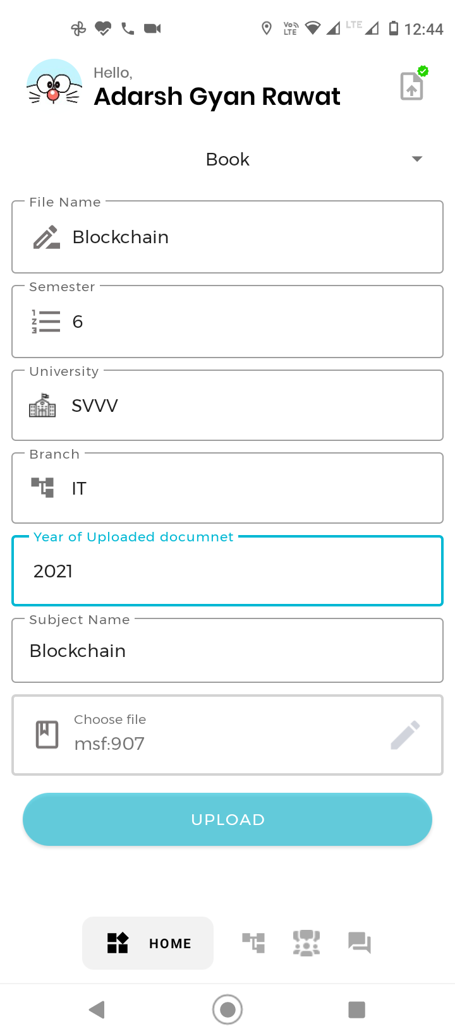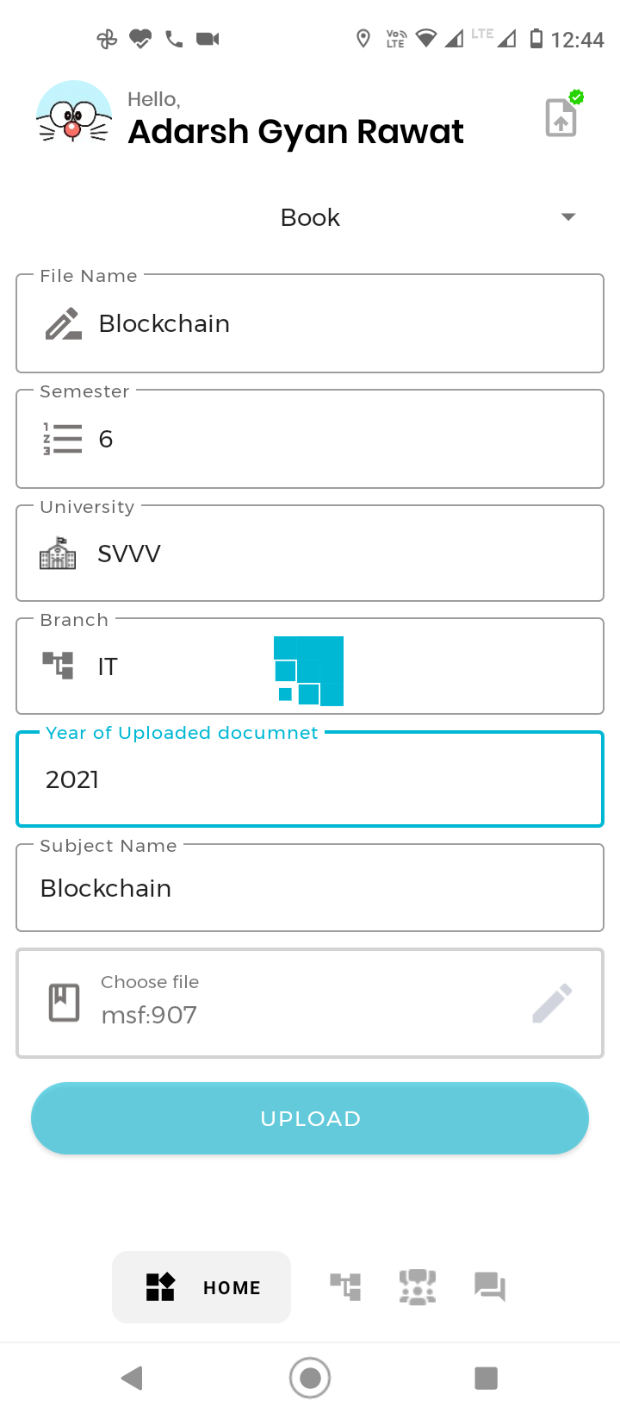

**7.1 7.2 7.3**

**8. Chat Section**

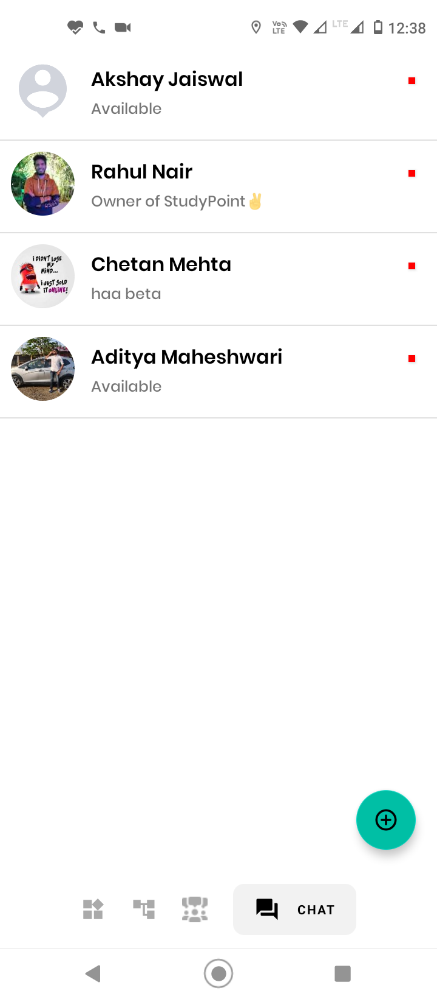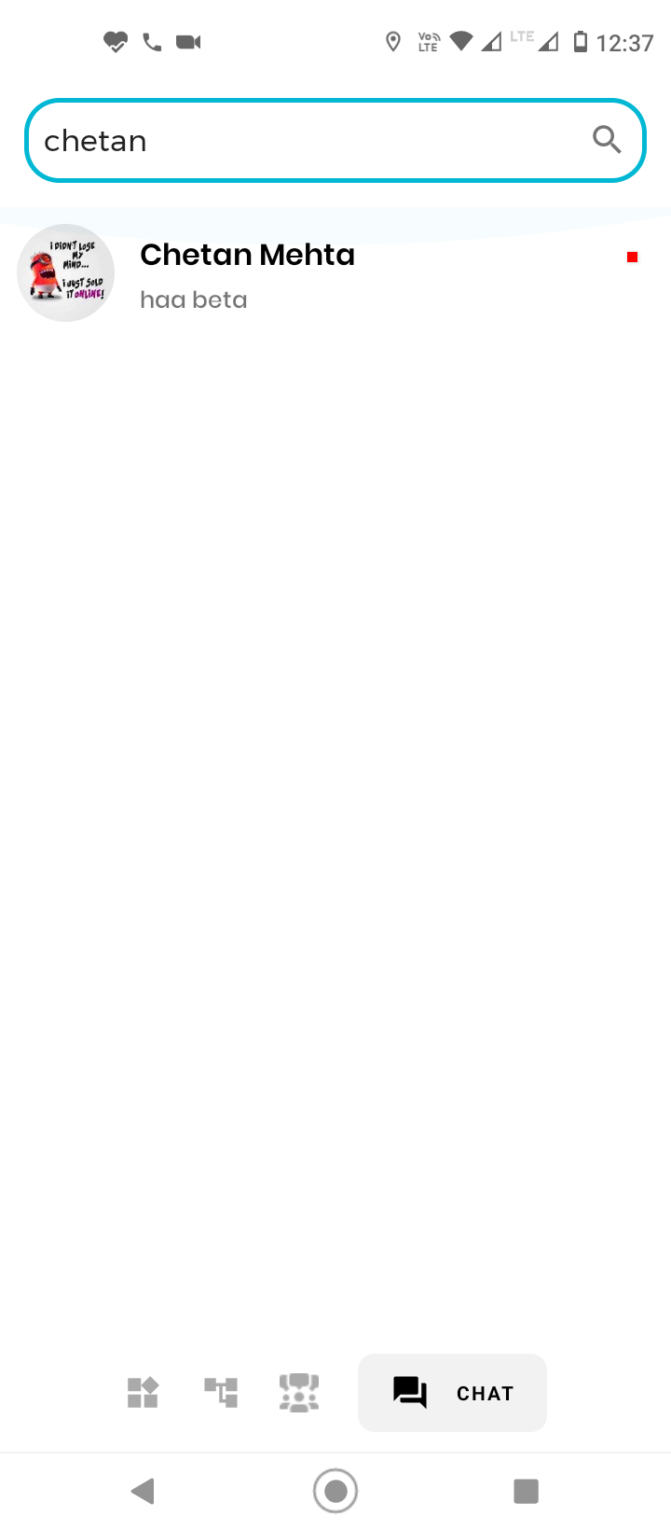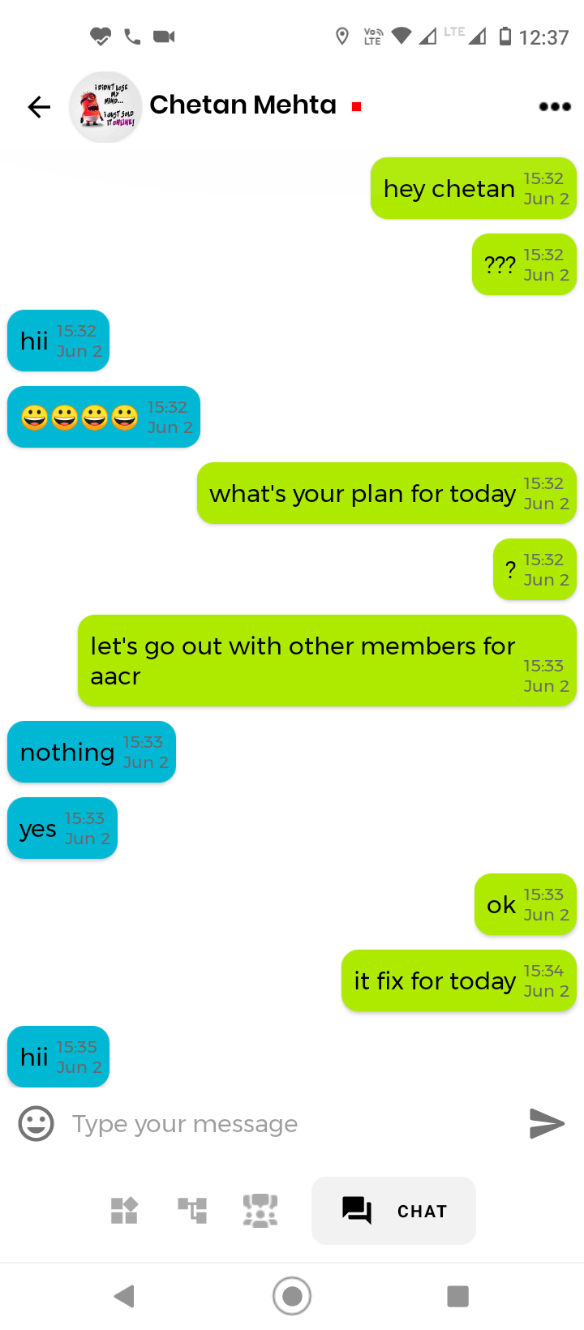

**8.1 8.2 8.3**

**9. Side-Bar Icons**

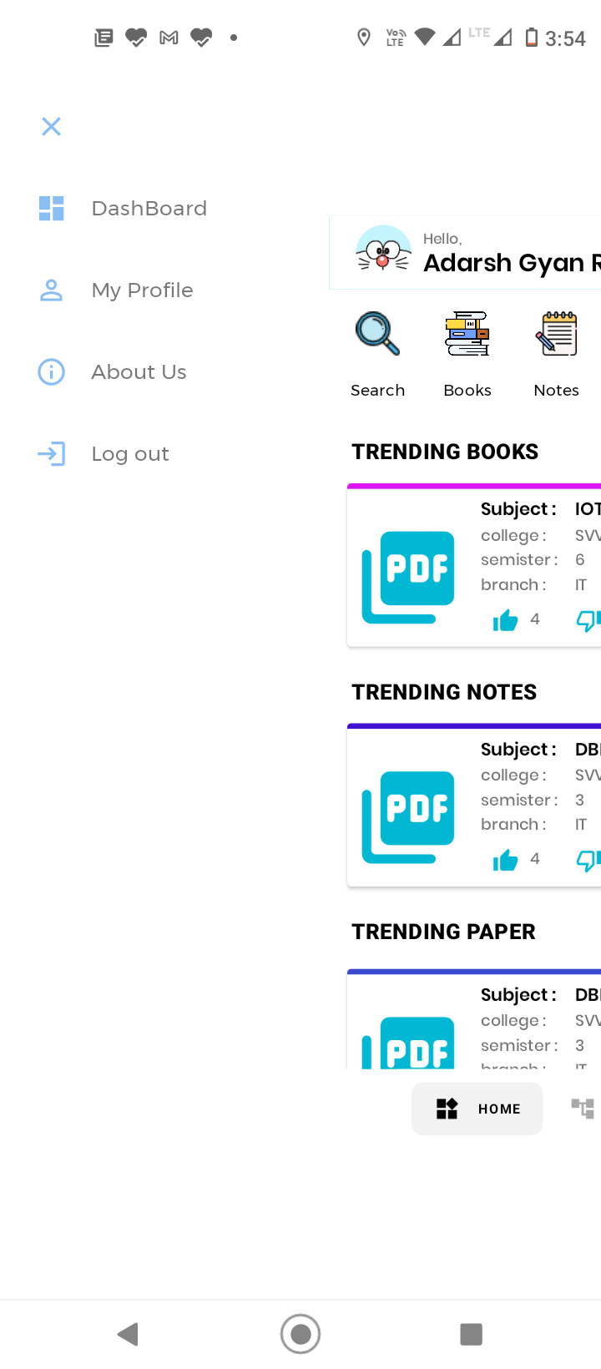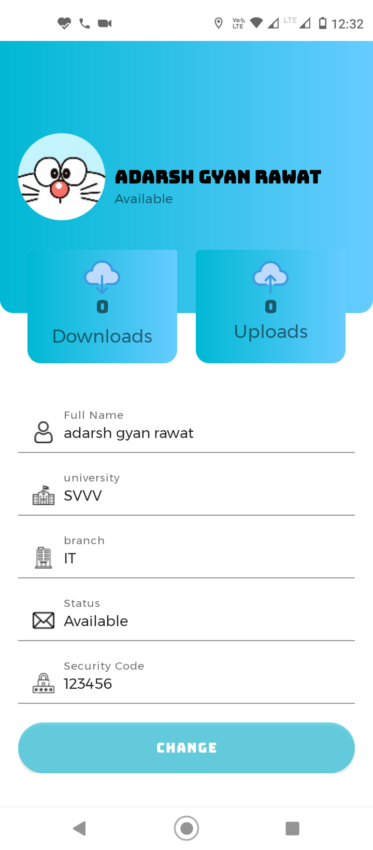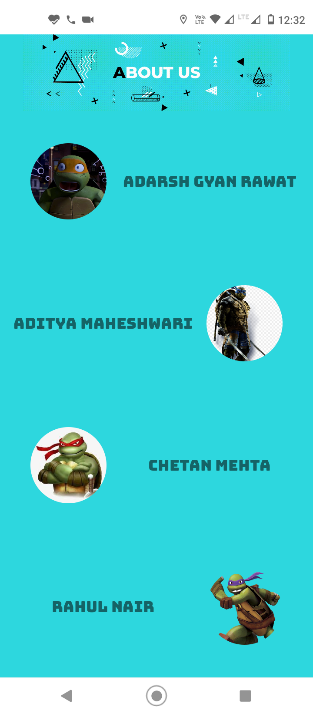

**9.1 9.2 9.3**

**10. Logout**

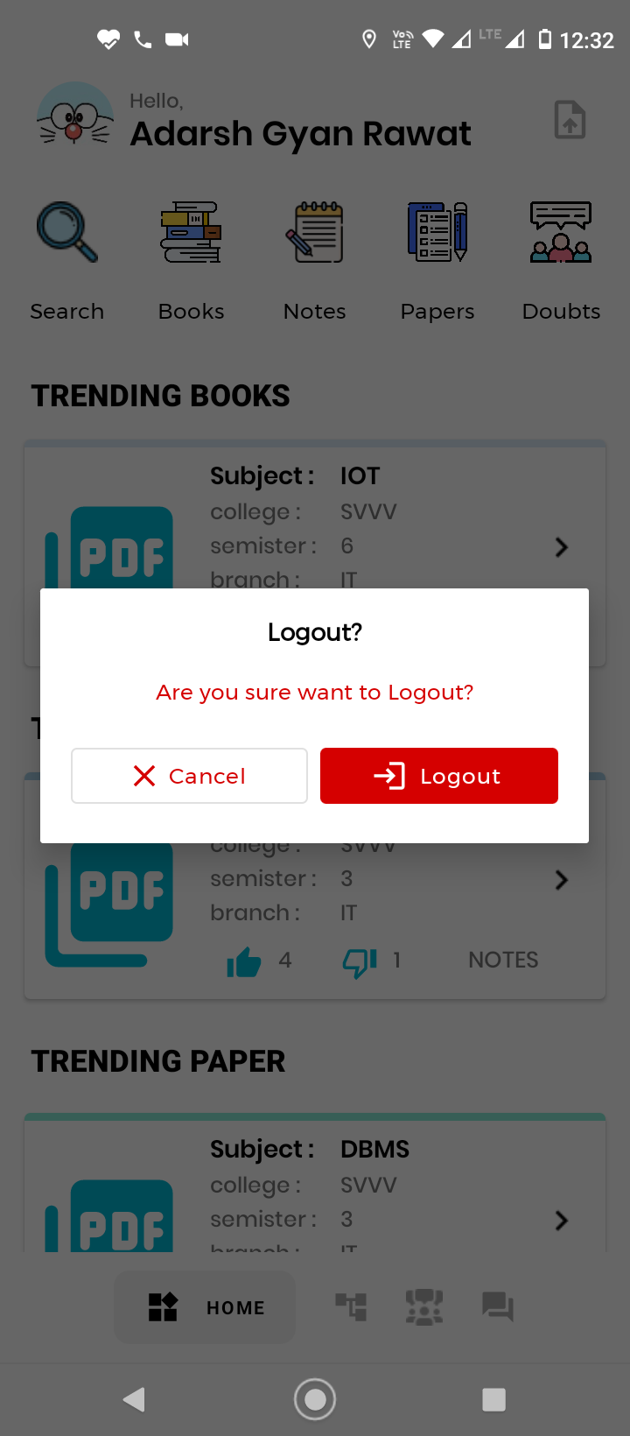

**10.1**